WEBSITE PROJECT PROPOSAL
Airbnb
Module: Web development
Module code: WEDE5020
Name: Fezile Ngwenya
Student number: ST10486745

Table of Contents
1. Organisation Overview 2
2. Website Goals and Objectives 3
3. Current Website Analysis 3
4. Proposed Website Features and Functionality 4
5. Design and User Experience 5
6. Technical Requirements 5
7. Timeline and Milestones 6
8. Budget (Estimated) 6
9. REFERENCE List 6

1. Organisation Overview
- Name
Airbnb was founded in 2008 by Brian Chesky, Joe Gebbia, and Nathan Blecharczyk. The founders began by renting out air mattresses in their San Francisco apartment to pay rent. It has since grown into a worldwide housing powerhouse, revolutionising the hotel market with innovative homestays and experiences. As of 2025, Airbnb has served more than 2 billion guests worldwide (wapbaike, 2025).
- Mision and vision
To create a world where anyone can belong anywhere. To shift from just a place to stay to a comprehensive travel concierge, integrating services, experiences, and accommodation into one seamless "Living Platform"(shoppingdesign, 2025).
- Target Audience
Millennial and Gen Z "Experience Seekers" (18-40) who prefer authentic, local living over standardised hotels (businessmodelanalyst,2025). Remote workers looking for long-term stays (28+ days).

2. Website Goals and Objectives
- Reduce booking abandonment at the "ID verification" stage by 20%.
- Improve the UI for host and guest verification to reduce friction during identity confirmation.
- Achieve a 25% cross-booking rate (users who book a home also book an experience/service).

3. Current Website Analysis
- Strengths:
- Award-winning Material Design with a focus on "pictures-first" layout that is clean, conversational, and unified across devices (ifanr, 2025).
- High user ratings (8.4k+ 5-star reviews) for ease of use.

- Weaknesses
The Wish List feature can be difficult to manage for users planning complex, multi-city trips.
Introduction of AI trip planner that combines wish lists and calendar availability to suggest an optimized route.

4. Proposed Website Features and Functionality
Site Map
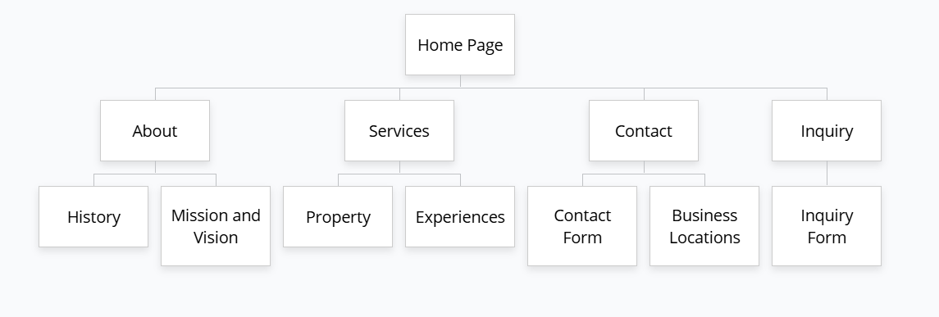

- A new UI feature that merges "Saved" homes, "Booked" reservations, and "Recommended Experiences" into a single timeline view.
- A step-by-step, interactive guide for new hosts using photo-recognition technology to suggest competitive pricing and house rules.

5. Design and User Experience
- Auto-playing, silent video loops in search results to give a preview of the property.
- Wireframe (Low-Fidelity)
- Header: Search Bar (Location -> Dates -> Guests) prominent at the top.
- Body: Staggered card grid. Each card features a large image, price, and a "Like" button .
- Bottom Nav (Mobile): Explore, Trips, Wishlist, Inbox, Profile.

6. Technical Requirements
- Hosting: AWS (Amazon Web Services) – leveraging global servers for low-latency images.
- Domain: Airbnb.com.
- API Integrations: Google Maps API for location visualization; Stripe/PayPal for secure payment processing.

7. Timeline and Milestones
Week 2-3, User research & Wireframing
Week 4-5, Backend integration for API
Week 6-7, Front-end implementation of new
Week 8, Beta testing for browser compatibility
Week 9, Accessibility
Week 10, Launch & Post-launch analytics setup

8. Budget (Estimated)
Development - R672 680 – R850 000
Hosting – 168 000/month
Maintenance – R134 000/month

9. Reference List
4. Business Model Analyst (2025) Airbnb目標市場分析. Available at: https://businessmodelanalyst.com/zh-TW/airbnb目標市場分析/ (Accessed: 30 March 2026).
5. iFanr (2025) 8 萬人滿分好評，Airbnb 如何拿下 Google 年度設計獎？ Available at: https://www.inside.com.tw/article/8705-airbnb-google-material-design-awards (Accessed: 30 March 2026).
6. ShoppingDesign (2025) Airbnb 介面全新改版！不再只是訂房網站. Available at: https://www.shoppingdesign.com.tw/topic/view/61/post/12138 (Accessed: 30 March 2026).
7. 百度百科 (2026) Airbnb. Available at: https://wapbaike.baidu.com/item/Airbnb (Accessed: 30 March 2026).

